*Input AC Signal*

*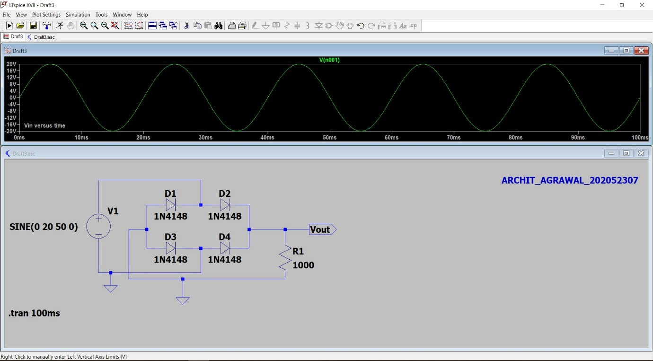*

*Output after full wave bridge rectification*

Converting the input AC sine wave to pulsating DC.

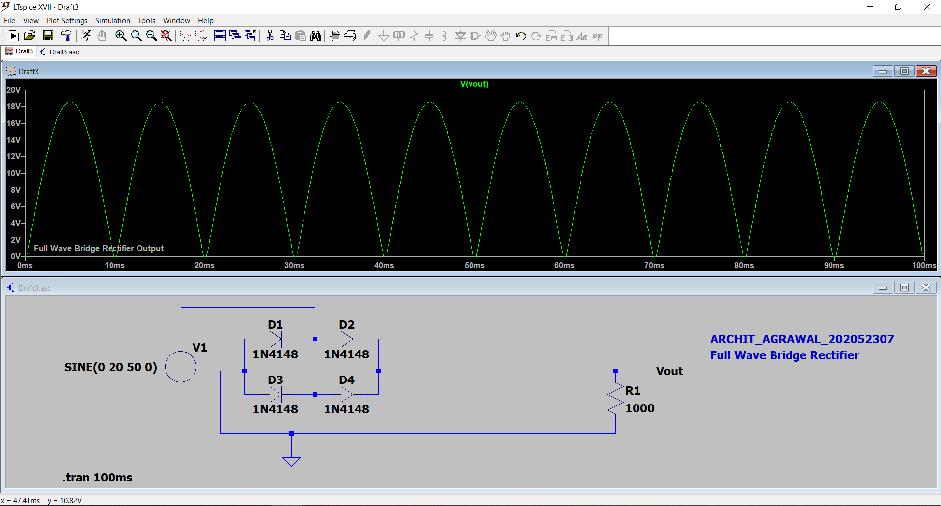

*Output after Capacitive Filter circuit*

Converting pulsating DC to Smooth DC.

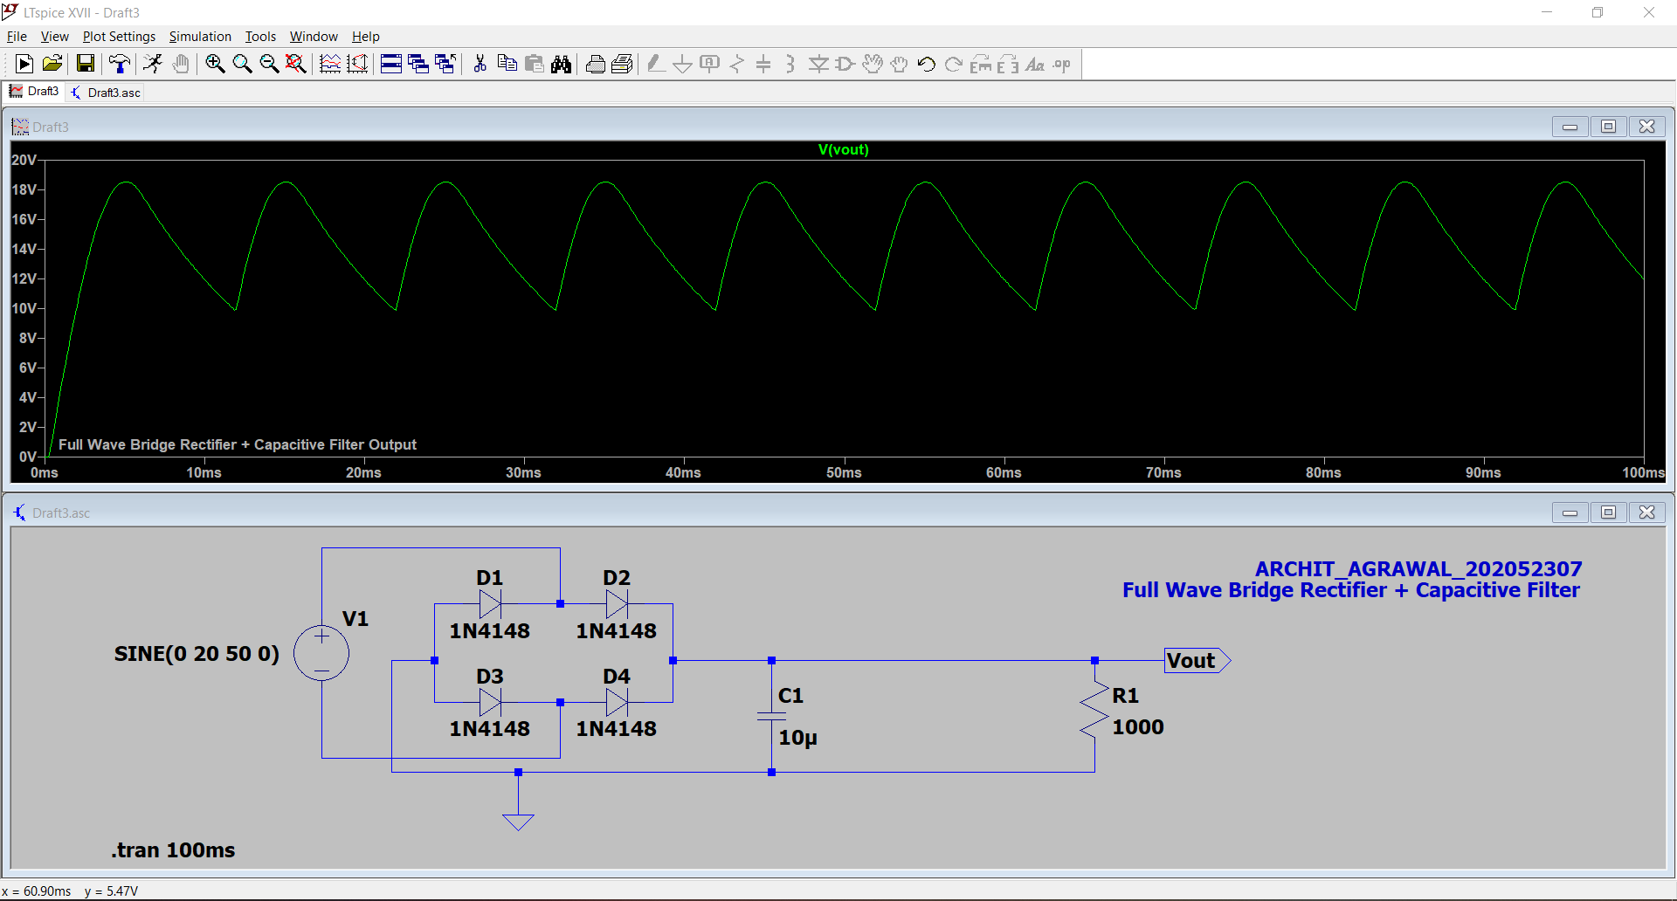

*Output after Zener Voltage Regulation*

Converting Smooth DC to Constant DC.

